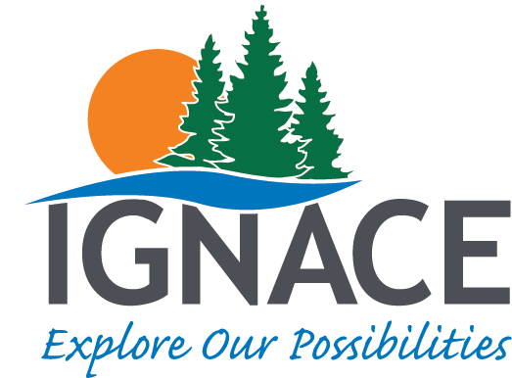
Township of Ignace
2021 Committee Application

Name: __________________________________
Address: _________________________________
________________________________________
________________________________________

Email: ___________________________________

Phone: __________________________________

Mobile: _________________________________

What committee are you interested in serving on?
- Economic Development Advisory Committee (EDAC) ____
- Ignace Citizens Advisory Committee (ICAC) ____
- Ignace Municipal Airport Advisory Committee (IMAAC) ____

Why do you want to be part of the team?
________________________________________________________________________________________________________________________________________________________________________________________________________________________________________________________________________________________________________________________________________________________________________________________________________________________________________________________________________________________________________________________________________________________________________________________________________________________________________________________________________________________________________
_____________________________________________________________________________________
_____________________________________________________________________________________

What is your relevant organizational/work experience?
________________________________________________________________________________________________________________________________________________________________________________________________________________________________________________________________________________________________________________________________________________________________________________________________________________________________________________________________________________________________________________________________________________________________________________________________________________________________________________________________________________________________________
_____________________________________________________________________________________
_____________________________________________________________________________________

Any other supporting documents/information.
_____________________________________________________________________________________________________________________________________________________________________________________________________________________________________________________________________________________________________________________________________________________________________________________________________________________________________________________________________________________________________________________________________________________________________________________________________________________________________________________________________________________________________________________________________________________________________________________________

NOTE: All volunteers are required by law to sign a code of conduct agreement.

The following is a brief description of what you will be undertaking as a committee member:

Economic Development Committee -The Economic Development Advisory Committee (ICAC) is a committee of Council, and its mandate is to facilitate community engagement to foster and promote a balanced and sustainable growth in the Township of Ignace. By researching and providing recommendations on (but not limited to): employment, business investment and the overall well-being issues in Ignace, the Committee will make comment on, advise and/or make recommendations through the Manager of Planning and Development Services to Council.
Citizens Advisory Committee – The Ignace Citizen Advisory Committee (ICAC) is a committee of Council. Its mandate is to facilitate community engagement through independent research and public testimony to address critical issues identified by Ignace community members and formulate recommendations through the Manager of Planning, Development and Engagement Services to Council to address those issues and promote well-being in the community.
Airport Committee – The Ignace Municipal Airport Advisory Committee (IMAAC) is a committee of Council. Its mandate is to independently research the viability and/or consider other uses of the facilities and make recommendations through the Manager of Planning, Development and Engagement Services to Council.

The interested individuals are invited to submit a letter of interest to the Township of Ignace at planning@ignace.ca or can contact the Township office (934-2202) to make arrangements to drop off their letter no later than Friday, January 15th, 2021 by 4 pm.

