­­

|  |  |
| --- | --- |
| Holiday Newsletter 2020 From the Mayor |  |
|  |  |

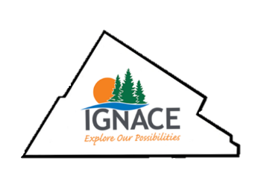

The holidays are a festive time of year when we share special moments with our family, friends and loved ones and look forward to a new year filled with promise and opportunity.

2020 has been an exceptional year for many reasons and we should reflect upon our many blessings. As the new Mayor in Ignace I am excited for what lies ahead. With new councils come new ideas and fresh perspectives and we will continue to work hard and build upon those new initiatives.

We need to listen more to one another and actively seek out ideas and encourage everyone who wants to contribute positively to our community. Reaching out, listening, planning and participating are essential ingredients in building a successful and happy place to live.

We need to have a strong belief in our ability to achieve remarkable things together.

Best wishes for the New Year!

Mayor Penny Lucas

Deputy Mayor Debbie Hart

Councillors Greg Waldock, Shawn Defeo, and Chantelle Tucker

­

|  |  |
| --- | --- |
| Holiday Newsletter 2020 The Township Family |  |
| Our Teams Our public works and office staff have seen some positive changes in the recent months and over the coming months we will be introducing everyone along with their roles via social media. The fire department and the water treatment plant also remain a vital part of our township staff. Plans for the New Year The township will continue to explore the Deep Geological Respository (DGR). We are also looking for members to sit on the Economic Development, Citizens Advisory and the Airport Committees. Mayor and Council have been extremely pleased at the number of participants on the council zoom meetings. It is energizing and exciting to see such an engaged community and we encourage future participation. |  |

|  |  |
| --- | --- |
| Township of Ignace |  |