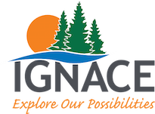
Ignace Citizen Advisory Committee Meeting Agenda
Tuesday, May 25, 2021

- Call to order

- Adopt Agenda

- Approval of Previous Minutes – 22 March 2021

- Presentation by Jeff Lederer on Community Engagement

- Business Arising from Minutes

- Old Business

- New Business

New members (other committees and overlap)
Plaza appearance concerns, Ignace area map updates, and fire hazards due to derelict vehicles and junk around town
Proposal of an off-leash dog park in the community
Scrap metal along the highway corridor

- Next Meeting – 22 June 2021

