**Update - Media Release**

23 April 2021

Road Closure Notice – Lakeshore Drive

The water line repairs on Lakeshore Drive have been completed, but the street will still be blocked off at 208 Lakeshore Drive to allow for the road material to settle and the road to become more stable. Everyone can still access their homes.

Ignace public works department is dealing with a broken water main at 208 - 210 Lakeshore Drive. Depending on which address you need to get to, you will need to access it from the appropriate roadway. Any address higher than 210 Lakeshore, you will need to access it from West Street, and any address lower than 210 Lakeshore you will need to access from Highway 17.

Thank you for your patience and understanding in this matter.

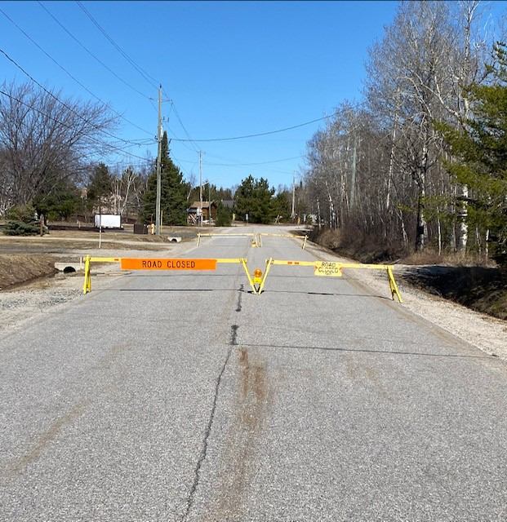

Township of Ignace – Public Works Department